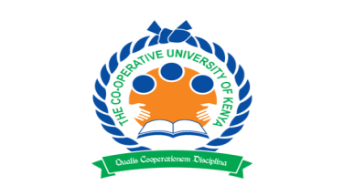
THE CO-OPERATIVE UNIVERSITY OF KENYA
P.O BOX 24814-00502, Karen-Nairobi Tel: 020-2430127/2679456
Fax: 0202470638

KELVIN MAINA HILDA,
DTMC01/0116/2016,
Tourism Management

My University
Category: Cultural Article.
With Kenya struggling with a nightmare of tribalism, institutions of higher learning play key role in promoting national integration and eradication of tribal stereotype. Cooperative University of Kenya has always been on the front line effortlessly promoting national integration and cohesion through admission of student from each and every corner of our magical Kenya making ita home away from home for the few Lucky students.

After admission, majority of girls will find themselves in D6 and Accra while boys will find themselves in D2-D5 and Kampala. A new culture will start forming right from rooms where you share with your roommates. Majority will introduce themselves with their first names and avoid their second names unless when submitting their assignments and during exam time. You are introduced to friends in second year to fourth year. After orientation and the famous fresher’s night, the fresh men and womenbecome fully integrated to the larger Cooperative University Fraternity.

A new culture is formed within Cooperative University peaceful and serene environment. Ranging from Academics, Sports, Entrepreneurship, Photography, Fashion, Fitness and Religion. Most of the students will be known for their exemplary performance and dedication in these university’s cultural categories. Others will still be proud of their native places of origin and represent their home culture in the university as evidenced by the recently concluded Cooperative University Cultural Week. While others will pretend to be Caucasian from abroad studying in Cooperative University of Kenya.

At the end of the day this new university culture will erase the tribal stereotype which some the students came with from home about people from other communities far from theirhome. By the end of your courseCooperative university of Kenya releasesan enthusiastic, dynamic and all-round graduate to take on the challenges facing our modern society and bring positive impactful change.

By KELVIN MAINAkelvinvilla116@gmail.com.

